Name :……………………………………………………………………Comb:…………..

Index No:………………………………School…………………………………………….

P525/1

**CHEMISTRY**

Paper 1

**June. July. 2022**

2¾ hours

***🕮***

***🖎***

**Community**

UNNASE MOCK EXAMINATIONS 2O22

**Uganda Advanced Certificate of Education**

**CHEMISTRY**

**PAPER 1**

**2hours 45minutes**

**INSTRUCTIONS TO CANDIDATES;**

* Answer **all questions in Section A** and **any six in Section B**.
* All questions must be answered in spaces provided.
* Illustrate your answers with equations where applicable.
* Molar gas constant, R=8.314jk-1mol-1
* Molar volume for a gas at s.t.p is 22400cm3
* Standard temperature =273k
* Standard pressure =101325 Nm-2

|  |  |  |  |  |  |  |  |  |  |  |  |  |  |  |  |  |  |  |
| --- | --- | --- | --- | --- | --- | --- | --- | --- | --- | --- | --- | --- | --- | --- | --- | --- | --- | --- |
| **FOR EXAMINERS USE ONLY** | | | | | | | | | | | | | | | | | | **Total** |
| **1** | **2** | **3** | **4** | **5** | **6** | **7** | **8** | **9** | **10** | **11** | **12** | **13** | **14** | **15** | **16** | **17** |  | |
|  |  |  |  |  |  |  |  |  |  |  |  |  |  |  |  |  |

1. (a) The data below was obtained from a certain reaction

|  |  |  |  |
| --- | --- | --- | --- |
| Experiment | $$\left[X\right]{moldm}^{-3}$$ | $$\left[Y\right]{moldm}^{-3}$$ | Initial rate $${moldm}^{-3}S^{-1}$$ |
| $$1$$ $$2$$ $$3$$ $$4$$ $$5$$ | $$0.1$$ $$0.1$$ $$0.1$$ $$0.2$$ $$0.3$$ | $$0.1$$ $$0.2$$ $$0.3$$ $$0.1$$ $$0.1$$ | $${1.0×10}^{-4}$$ $${4.0×10}^{-4}$$ $${9.0×10}^{-4}$$ $${1.0×10}^{-4}$$ $${1.0×10}^{-4}$$ |

(i) Determine the order of this reaction with respect **X** and **Y**.

(2 marks)

**……………………………………………………………………………………………**

**……………………………………………………………………………………………**

**……………………………………………………………………………………………**

(ii) What is the overall order of the reaction? (½ marks)

**……………………………………………………………………………………………**

(b) (i) Write the rate equation for the reaction. (01 mark)

**……………………………………………………………………………………………**

(ii) Calculate the rate constant for the reaction and give its units.

(1½ marks)

**……………………………………………………………………………………………**

**……………………………………………………………………………………………**

2. (a) What is meant by the term **diagonal relationship**. (01 mark)

**……………………………………………………………………………………………**

**……………………………………………………………………………………………**

**……………………………………………………………………………………………**

(b) Give **three** properties in which beryllium resembles aluminium. (03 marks)

**……………………………………………………………………………………………**

**……………………………………………………………………………………………**

**……………………………………………………………………………………………**

(c) Name another pair of elements from group (III) and IV that exhibit the

behavior in (a).

**……………………………………………………………………………………………**

**……………………………………………………………………………………………**

**……………………………………………………………………………………………**

3. Using equations show how the following conversions can be brought about.

(a) to (3 marks)

**……………………………………………………………………………………………**

**……………………………………………………………………………………………**

**……………………………………………………………………………………………**

**……………………………………………………………………………………………**

(b) ${CH}_{3}CH{CH}_{3} to {CH}_{3}CH{CH}_{2}Cl$ (2½ marks)

**……………………………………………………………………………………………**

**……………………………………………………………………………………………**

**……………………………………………………………………………………………**

**……………………………………………………………………………………………**

4. A hydride of solution **R**, contains 87.5% silicon **R** has a density of

${1.429×10}^{-3}{g/cm}^{3} at s.t.p$

**Determine**

(i) the empirical formula of **R**. (2 marks)

**……………………………………………………………………………………………**

**……………………………………………………………………………………………**

**……………………………………………………………………………………………**

(ii) the molecular formula of **R**. (1½ marks)

**……………………………………………………………………………………………**

**……………………………………………………………………………………………**

**……………………………………………………………………………………………**

(b) The hydride of silicion in (a) (i) is hydrolysed by water in alkaline medium,

however the corresponding hydride of carbon does not undergo hydrolysis.

(i) Write equation for the hydrolysis of silicon hydride. (1½ marks)

**……………………………………………………………………………………………**

**……………………………………………………………………………………………**

(ii) Give a reason why the hydride of carbon does not undergo

hydrolysis. (1 mark)

**……………………………………………………………………………………………**

**……………………………………………………………………………………………**

**……………………………………………………………………………………………**

**……………………………………………………………………………………………**

**……………………………………………………………………………………………**

**……………………………………………………………………………………………**

5. (a) Draw the structure and name the shapes of the following species.

|  |  |  |
| --- | --- | --- |
| Species | Shape | Structure |
| (i) ${ NO}_{3}^{-}$ |  |  |
| (ii) ${SO}_{3}^{2-}$ |  |  |

(b) Oxygen form two halides, $OF_{2}$ and ${Cl}_{2}O$. Explain the differences in bond

angle between these two halides of oxygen. (2½ marks)

**……………………………………………………………………………………………**

**……………………………………………………………………………………………**

**……………………………………………………………………………………………**

**……………………………………………………………………………………………**

6. A compound **W** contains 22.5% phosphorus the rest being chlorine

(the molecular mass of W=137.5)

(a) Determine the molecular formula of W. (03 marks)

**……………………………………………………………………………………………**

**……………………………………………………………………………………………**

**……………………………………………………………………………………………**

(b) Explain what happens if **W** reacted with water. (2½ marks)

**……………………………………………………………………………………………**

**……………………………………………………………………………………………**

**……………………………………………………………………………………………**

7. Complete the following equations and in each case write a mechanism.

(a) ${CH}_{3}CH{CH}_{3} \begin{matrix}Conc.H_{2}{SO}_{4} \\ {180}^{0}\end{matrix}$ (3 marks)

$$OH$$

**……………………………………………………………………………………………**

**……………………………………………………………………………………………**

**……………………………………………………………………………………………**

**……………………………………………………………………………………………**

**……………………………………………………………………………………………**

(b) ${CH}_{3}C={CH}_{2} HBr$ (2 marks)

**……………………………………………………………………………………………**

**……………………………………………………………………………………………**

**……………………………………………………………………………………………**

**……………………………………………………………………………………………**

**……………………………………………………………………………………………**

8. (a) Define the term **partial pressure**.

**……………………………………………………………………………………………**

**……………………………………………………………………………………………**

**……………………………………………………………………………………………**

(b) The vapour pressures of pure carbon tetrachloride and trichloromethane

are 114.5 and 199.1 mmHg respectively at 250C.

(Assume that a mixture of the two liquids behaves as an ideal gas and it

contains 0.96 mole of each pure liquid. Calculate:

(i) the partial pressure of each component in the mixture.(2½ marks)

**……………………………………………………………………………………………**

**……………………………………………………………………………………………**

**……………………………………………………………………………………………**

**……………………………………………………………………………………………**

**……………………………………………………………………………………………**

(ii) the total pressure. (½ mark)

**……………………………………………………………………………………………**

**……………………………………………………………………………………………**

(c) Calculate the percentage of carbon tetrachloride in the vapour in

equilibrium with the liquid mixture. (1 mark)

**……………………………………………………………………………………………**

**……………………………………………………………………………………………**

9. (a) A compound M, of relative molecular mass 93, burns with a sooty, flame

and contains 77.42% carbon, 7.53% hydrogen and the rest being nitrogen.

Determine the molecular formula of M. (3 marks)

**……………………………………………………………………………………………**

**……………………………………………………………………………………………**

**……………………………………………………………………………………………**

**……………………………………………………………………………………………**

(b) Using equations show how M can be formed from benzene. (2 marks)

**……………………………………………………………………………………………**

**……………………………………………………………………………………………**

**……………………………………………………………………………………………**

**……………………………………………………………………………………………**

**……………………………………………………………………………………………**

**SECTION B**

10. Sulphur dioxide reacts with oxygen according to the following equation.

${SO}_{2}\left(g\right)+O_{2}\left(g\right) 2{SO}_{3}\left(g\right)∆H=-98kj{mol}^{-1}$

(a) State the conditions for the reactions that would favour maximum yield of

sulphur trioxide. (1½ marks)

**……………………………………………………………………………………………**

**……………………………………………………………………………………………**

**……………………………………………………………………………………………**

(b) State what would happen to the concentration of sulphur trioxide in the

equilibrium mixture and give a reason for your answer if

(i) the temperature was increased. (1½ marks)

**……………………………………………………………………………………………**

**……………………………………………………………………………………………**

**……………………………………………………………………………………………**

(ii) Nitrogen gas was added to the mixture at constant pressure.

(1½ marks)

**……………………………………………………………………………………………**

**……………………………………………………………………………………………**

**……………………………………………………………………………………………**

(c) For the following gas equilibrium. $N_{2}O_{4}\left(g\right) 2{NO}_{2}(g)$,

If the equilibrium constant, kp is 1.33 atmospheres.

Calculate the degree of dissociation of 1 mole of $N_{2}O_{4} at 333k$ if the total

pressure of the system is 2 atmospheres. (4½ marks)

**……………………………………………………………………………………………**

**……………………………………………………………………………………………**

**……………………………………………………………………………………………**

**……………………………………………………………………………………………**

**……………………………………………………………………………………………**

**……………………………………………………………………………………………**

11. State what would be observe and write equation for the reaction that would take place when;

(a) Tin (II) chloride is added to acidified potassium manganite (VII) solution.

(2½ marks)

**Observation**

**……………………………………………………………………………………………**

**……………………………………………………………………………………………**

**Equation**

**……………………………………………………………………………………………**

**……………………………………………………………………………………………**

(b) Hydrogen sulphide is bubbled through iron (III) chloride solution.

(2 marks)

**Observation**

**……………………………………………………………………………………………**

**……………………………………………………………………………………………**

**Equation**

**……………………………………………………………………………………………**

**……………………………………………………………………………………………**

(c) Acidified hydrogen peroxide is added to a solution of potassium chromate

(VI). (2½ marks)

**Observation**

**……………………………………………………………………………………………**

**……………………………………………………………………………………………**

**Equation**

**……………………………………………………………………………………………**

**……………………………………………………………………………………………**

(d) 3 drops 2,4 – dinitrophenylhydrazine was added to an aqueous solution of

propanone. (3 marks)

**Observation**

**……………………………………………………………………………………………**

**……………………………………………………………………………………………**

**Equation**

**……………………………………………………………………………………………**

**……………………………………………………………………………………………**

12. Name a reagent that can be used to distinguish the following species; in each case state what would be observed if the named reagent reacted separately with each member of the pair.

(a) $C_{6}H_{5}OH and C_{6}H_{5}COOH$ (3 marks)

**Reagent**

**……………………………………………………………………………………………**

**……………………………………………………………………………………………**

**Observation**

**……………………………………………………………………………………………**

**……………………………………………………………………………………………**

(b) ${CH}_{3}CH{CH}_{2}OH and {\left({CH}_{3}\right)}_{3}COH$ (03 marks)

$${CH}_{3}$$

**Reagent**

**……………………………………………………………………………………………**

**……………………………………………………………………………………………**

**Observation**

**……………………………………………………………………………………………**

**……………………………………………………………………………………………**

$$O$$

(c) and (3 marks)

$${CH}_{2}CHO$$

$${CCH}_{3}$$

**Reagent**

**……………………………………………………………………………………………**

**……………………………………………………………………………………………**

**Observation**

**……………………………………………………………………………………………**

**……………………………………………………………………………………………**

13. To an aqueous solution of ${CuSO}_{4}.{5H}_{2}O$ was added concentrated hydrochloric

acid drop wise until in excess.

(a) (i) Name the copper species present in the solution before hydrochloric

acid was added. (1 mark)

**……………………………………………………………………………………………**

**……………………………………………………………………………………………**

(ii) Write the formula of the copper species in the solution containing the

excess hydrochloric acid. (1 mark)

**……………………………………………………………………………………………**

**……………………………………………………………………………………………**

(b) The solution containing excess hydrochloric acid was diluted with excess

water.

(i) State the colour change that took place. (1 mark)

**……………………………………………………………………………………………**

**……………………………………………………………………………………………**

(ii) Write equation for the reaction that took place. (1 mark)

**……………………………………………………………………………………………**

**……………………………………………………………………………………………**

(c) 0.8g of copper ore was leached with dilute sulphiric acid and the resultant

solution was diluted to 250cm3. To 30cm3 of this solution was added 10%

potassium iodide solution. The liberated required 23.5cm3 of 0.05M sodium

thiosulphate solution for complete reaction.

Calculate the percentage of copper in the ore. (4½ marks)

**……………………………………………………………………………………………**

**……………………………………………………………………………………………**

**……………………………………………………………………………………………**

**……………………………………………………………………………………………**

**……………………………………………………………………………………………**

**……………………………………………………………………………………………**

14. Enthalpies / heats $∆H^{0}C$ of combustion of some substances are given below

Substance ${∆H}^{0}C(kj{mol}^{-1})$

Hydrogen $242$

Benzene $3302$

Cyclohexene $3746$

Cyclohexane $3940$

(a) Calculate the enthalpy (heat) of hydrogenation

(i) Cyclohexene (3 marks)

**……………………………………………………………………………………………**

**……………………………………………………………………………………………**

(ii) Benzene (3 marks)

**……………………………………………………………………………………………**

**……………………………………………………………………………………………**

(b) Comment on the differences in the enthalpies of hydrogenations of

cyclohexene and benzene that you calculated in (a) with reference to the

structures of the two compounds. (3 marks)

**……………………………………………………………………………………………**

**……………………………………………………………………………………………**

**……………………………………………………………………………………………**

**……………………………………………………………………………………………**

**……………………………………………………………………………………………**

15. Complete the following equations and in each case write a mechanism

(a) ${CH}_{3}CHCHO {NaHSO}_{3} Na{HSO}_{3}$ (3½ marks)

$$CH_{3}$$

**……………………………………………………………………………………………**

**……………………………………………………………………………………………**

**……………………………………………………………………………………………**

**……………………………………………………………………………………………**

**……………………………………………………………………………………………**

(b) ${CH}_{3}{CH}_{2}Cl \begin{matrix}KOH/{CH}_{3}{CH}_{2}OH \\ heat\end{matrix}$ (2 marks)

**……………………………………………………………………………………………**

**……………………………………………………………………………………………**

**……………………………………………………………………………………………**

(c) $\begin{matrix}Conc.{HNO}_{3} \\ Conc.H_{2}{SO}_{4}{60}^{0}C\end{matrix}$ (3½ marks)

**……………………………………………………………………………………………**

**……………………………………………………………………………………………**

**……………………………………………………………………………………………**

**……………………………………………………………………………………………**

**……………………………………………………………………………………………**

16. Write equation for the reactions that take place when the following substances react with acqueous sodium hydroxide and water

(a) **Sodium hydroxide and**

(i) $PbO$ (1½ mark)

**……………………………………………………………………………………………**

**……………………………………………………………………………………………**

(ii) ${SnO}_{2}$ (1½ mark)

**……………………………………………………………………………………………**

**……………………………………………………………………………………………**

(iii) ${CrO}_{3}$ (1½ mark)

**……………………………………………………………………………………………**

**……………………………………………………………………………………………**

(b) water and

(i) $P_{2}O_{5}$ (1½ mark)

**……………………………………………………………………………………………**

**……………………………………………………………………………………………**

(ii) ${Cl}_{2}O_{7}$ (1½ mark)

**……………………………………………………………………………………………**

**……………………………………………………………………………………………**

(iii) ${SiO}_{2}$ (1½ mark)

**……………………………………………………………………………………………**

**……………………………………………………………………………………………**

17. (a) Using relevant equations outline how concentrated sulphiric acid can be

manufactured from sulphur or iron pyrites, ${FeS}_{2}$. (5½ marks)

**……………………………………………………………………………………………**

**……………………………………………………………………………………………**

**……………………………………………………………………………………………**

**……………………………………………………………………………………………**

**……………………………………………………………………………………………**

**……………………………………………………………………………………………**

(b) Briefly discuss the reactions of concentrated sulphiric acid with

(i) Copper metal (2 marks)

**……………………………………………………………………………………………**

**……………………………………………………………………………………………**

**……………………………………………………………………………………………**

(ii) Sulphur (1½ mark)

**……………………………………………………………………………………………**

**……………………………………………………………………………………………**

**……………………………………………………………………………………………**

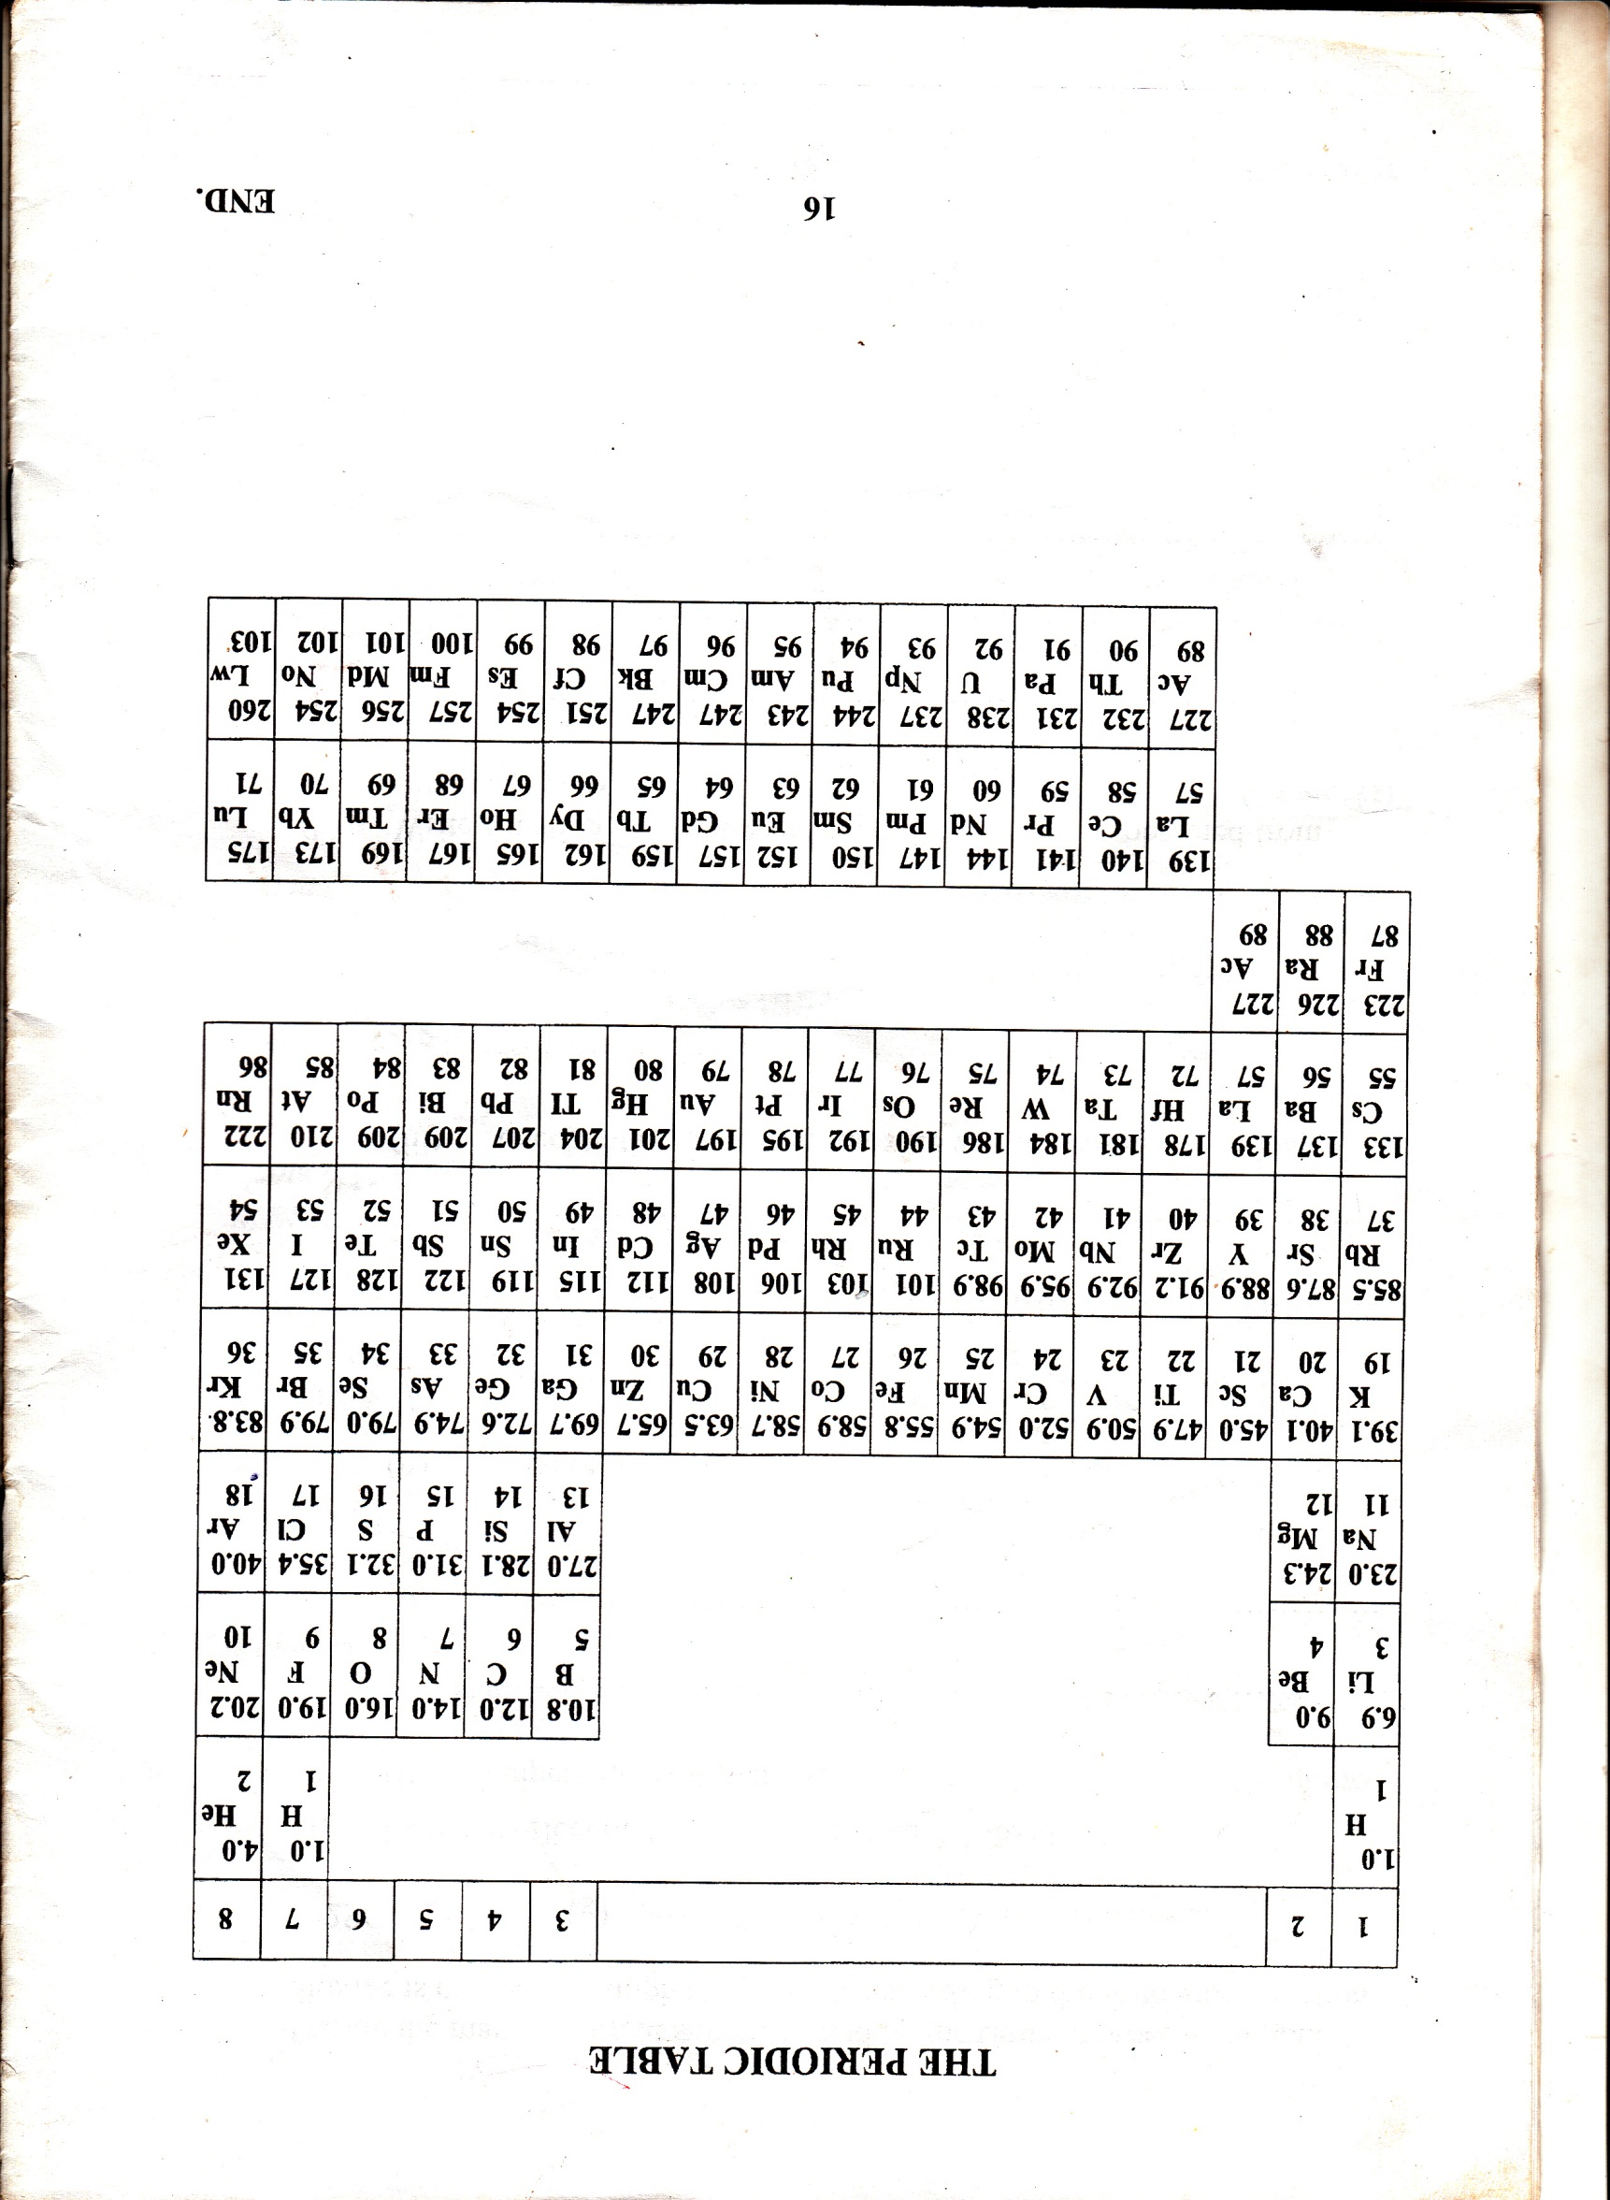

**END**